A000-Asia-China-Hongshan-Owl-Jade-3500-2200 BCE

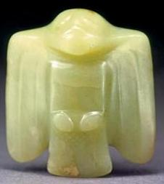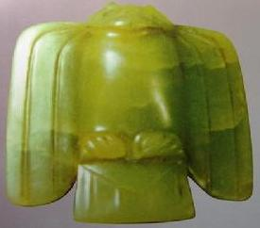

Figs. 1-2. Figs. 1-2 Hongshan-Owl-Jade-3500-2200 BCE.

**Case No.: 5**

**Accession No.**

**Formal Label:** Hongshan-Owl-Jade-3500-2200 BCE.

**Display Description:**

The owl probably with wings swept back ise represented in a frontal, prey pursuing posture, and reveal a Hongshan conception of an aviary type of carnivorous creature. The adeptness of the hunting bird of prey was also found ensconced in clay-molded fragmentary birds in the Goddess Temple where two bird claws were found in a votary context indicating some form of bird worshi**p** along with some bear related fragments, and these may have been the fragmentary parts of one or more so-called dragon bodies.

This Owl pendant of green jade silicate (oltrelite) is translucent celadon green.The holes have been blind drilled with ancient hand tools on the back of the pendant. Within a Neolithic time-horizon of 4700-2920 BCE Hongshan owl symbolism was developed that was incorporated into jade objects, which were produced by élite artisans supported by the political élites. These artisans developed an iconographic display of power in jade artifacts the value of which was beyond the reach of commoners.

Why the owl?  The terrifying screech and nocturnal behavior of the owl would have fit perfectly the perception of abnormality in ritual and magic; its physical appearance also reminds people of a warrior. In early Chinese jade pendants, bird motifs are highly stylized, and the owl is one of the most prominent and most mysterious of bird images. Of the nearly 30 different subspecies of the owl family, among those selected by jade artists are the long-eared Eurasian eagle owl (*diao xiao*) and the long-eared owl (*chang’er xiao*). In its natural habitat, the owl with binocular vision and binaural hearing, is a superb nocturnal bird. Associated with the dark, the owl is also associated with the realm of the dead and dreams. Accordingly, the Neolithic tradition of jade carvings of small owl-like birds at sites of the Hongshan culture (4700-2920 BCE) in northeast China has revealed they were buried in tombs of local chiefs or shamans.

Since the Hongshan left no written records we have to look to one of their successors, the Shang people, who adopted the owl for significant rôles in their belief system. In fact, the Shang believed that they had originated from a mythical black-bird (*xuanniao*), an owl, which became their totem (Houxuan 1964).   According to Sun Xinzhou, strigidae (owl) worship existed in the Shang dynasty, and the mythical ancestor Di Jun (also known as Di Ku, Shun) can be identified with the bird deity who was also the productive god, agriculture protector and solar god for the Shang people7. Although his argument is grounded in the old totemic framework, the suggestion of the owl being the *xuanniao* or black bird is certainly worthy of investigation.

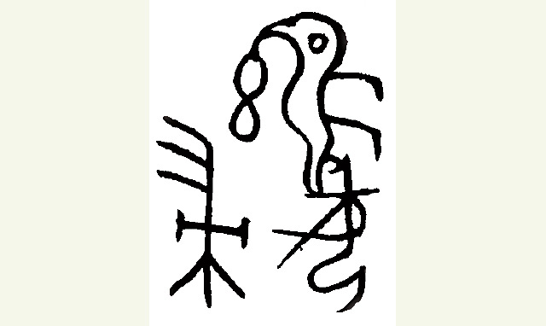

Fig. 12

The myth of the origin of the Shang people is found in *The Book of Songs* (“Heaven bade the dark bird”) . Of course, this song cannot be regarded as an original record of the Shang dynasty.  It is more likely that it was transmitted orally through the Shang into the Zhou period, with slight variations over time. In Shang and Zhou lexicography, the word *xuan* (black) can also be understood as “mysterious” or “divine”8,  and in Shang oracle bone inscriptions, we find a pictograph depicting a beaked owl with round eyes and plump torso, which is the name of a star, or it can be rendered as the character standing for the owl itself (*Heji*: 522, 11497, 11498, 11499, 11500).  In other cases, it is used together with the ancestral names Fu Gui and Fu, and  can be interpreted as “Father Gui of the Owl clan” (fig. 11) and “Lady of the Black Owl clan” (fig. 12). Thus, the evidence from Shang archaeology and historical literature render it quite possible that the Shang people believed in some mythical relationship with the owl. Liu Dunyuan has argued that the Shang people perceived the owl as the god of night and dreams, as well as the messenger between the human and the spirit world – on account of its silent flight and hunting in darkness9.  If so, this would explain why the owl is employed repeatedly in Shang ritual art and is found in a burial context, as we have seen in the examples previously discussed.

**LC Classification:** NK5750.2.C6

**Date or Time Horizon:** 4700-2920 BCE

At ca 8,000 BCE four sites in three provinces attest to the beginnings of agriculture identified by excavated domesticated phytoliths paired with solely wild faunal remains (Huang 1966; Yan 1997): Hebei (the Nanzhuangtou site 39° N lat. in Xushui County, Baoding Institute et al. 1992), Hunan (the Yucanyan site in Dao County, 25.5° N lat.) and Jiangxi (Xianrendong and Diaotonghuan 28.5° N lat., Yan 1997, in Wannian County). These sites represent transitional Hunter-gatherer / Neolithic cultures.

At ca 6,000 BCE Asians with the D haplogroup living in the Yangtze River delta domesticated both foxtail millet (Wu et al. 2007) and wild boars. In Hebei (Wu’an County, 36.5° N lat.) at the Cishan site (Jing and Flad 2002) burial pits of domesticated wild boars were overlain by charred, domesticated foxtail millet (Jing and Flad 2002; Jing et al. 2008). Domesticated foxtail millet, a C4 plant that cycles CO2 into four-carbon sugar compounds, is very efficient in hot, dry climates and was an important component of both the human and swine diets (Jing and Flad 2002). The discarded chaff of domesticated cereals appears to have been used to feed wild boars. Domesticated wild boars have been identified by tooth size (lower 3rd molar L41.4, W 18.3), age at slaughter (> 60%, .5-1 yr.) and archaeological context such as ritual burial of entire skeletons beneath charred foxtail millet.

**Geographical Area:** In 1976, archaeologists from the Institute of Archaeology, Chinese Academy of Social Sciences, discovered in Xiaotun village an intact royal tomb which belonged to Fu Hao, one of the consorts of King Wu Ding.  A number of small jade owls were found in her tomb, together with a pair of large bronze wine vessels (*zun*) made in the shape of standing owls (figs. 6 & 7).

**Map:**

**GPS coordinates:**

**Cultural Affiliation:**

**Media:**

**Dimensions:**

**Weight:**

**Condition:**

**Provenance:**

**Discussion:**

These emergent Neolithic Hongshan people, who secured both economic control over these two inter-related animal and plant food resources and consolidated their political power through manipulation of these resources of productive wealth, were speakers of Altaic, either pre-Mongolic or Korean but not Sinitic (Blench 2004; but see Guo 1995).

By 6000 BCE the Yangtze River delta had emerged as an area of importance for the development of a dual domesticated boar and foxtail millet economy. In order to gain the respect of the masses political élites doled out to the commoners not only grain and pork (Flannery 1968, Bradley 1972, Frankenstein and Rowlands 1978, Kristiansen 1991, Saenz 1991) but also prestige goods such as jade and silk (Firth 1965; Leach 1970:162-63).

References:

Allan, Sarah . 1997. The Shape of the Turtle: Myth, Art and Cosmos in Early China, Albany, esp. Chapter 2.

Bagley, Robert. 1980. “The Appearance and Growth of Regional Bronze Cultures” in Wen Fong, ed. *The Great Bronze Age of China*, New York: 111-9.

Bagley, Robert. 1987. *Shang Ritual Bronzes in the Arthur M. Sackler Collections*, New York, pp. 360-7.

Blench, Roger. 2004. “Human migrations in continental East Asia and Taiwan: genetic, linguistic and archaeological evidence. Université de Genève” [DRAFT CIRCULATED FOR COMMENT]

Dunyuan. Liu. 2012. “Ye Yu Meng Zhishen de Chixiao” (The owl: deity of night and dreams), in Collected Papers of Liu Dunyuan, Beijing, pp. 159-71.

Guo, Da-Shun 1995. Hongshan and related cultures. In: *The archaeology of Northeast China: beyond the Great Wall.* Nelson, Sarah M. ed. 21-64. London and New York: Routledge.

Guo D. 1985. *Hongshan Culture (*红山文化). Beijing: Artifacts Press.

Hung, Wu.1995. *Monumentality in Early Chinese Art and Architecture*. Stanford: Stanford University press, pp. 48, 53.

Houxuan, Hu . 1964. “Jiaguwen Shangzu niaotuteng de yiji”, (The surviving evidence of the Shang bird totemic worship in oracle bone inscriptions), *Lishi luncun*, no. 1: 131-59;

Houxuan, Hu . 1977. “.Jiaguwen suojian Shangzu niaotuteng de xin yiji” (New evidence of the Shang bird totemic worship in oracle bone inscriptions), *Wenwu*, 2:.84-7.

Shuowen jiezi (Xu Shen, 1st Century): “The owl is an unfilially bird; so, on the rizhi day people catch owls and slaughter them.”

Shuxian, Ye . 2006. “Jingdian de wudu yu zhishi kaogu—yi ‘Shijing Chixiao’ weili” (Misunderstanding of Classics and archaeology of knowledge—taking ‘the owl’ poem in the Book of Songs as an example),  Journal of the Shaanxi Normal University (Social Science), Vol. 35 no. 4, July, pp. 56-64.

Waley, Arthur. 1988. *The Book of Songs*,  New York: Grove Press, pp. 275-6. Romanization of Chinese names has been changed to pinyin system

Wang Tao. 1996. “Colour terms in Shang oracle bone inscriptions”, BSOAS, 59(1): 63-101;  “Qingyou gaozu xinjie” (Dark-blue ancestors: The relationship between space and colour in ancestral worship), in Chrystelle Maréchal & Yau Shun-chiu, eds., Actes des symposiums internationaux Le Monde visuel chinois,  Paris, 2005, pp. 269-80.

Wang, Eugene Y. 2009. “Why pictures in Tombs? Mawangdui Once More,” *Orientations*, March.

Xinzhou, Sun . 2004. “Chixiao Chongbai yu Huaxia Lishi Wenming,” (On the strigidae worship and historical civilization in China) *Journal of Tianjin Normal University* (Social Sciences), no. 5: 31-7.